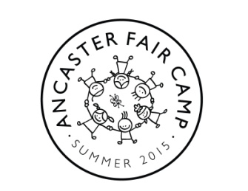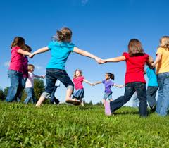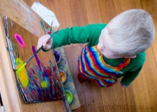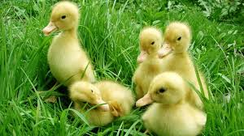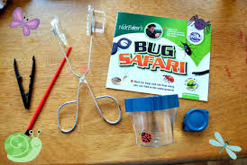
NEW DAYCAMP AT ANCASTER FAIR

Looking for something fun, different, educational and local for your kids 5 -13 to do this summer?
Ancaster Fair Camp is focused on:
- Environment and agriculture
- Arts and crafts
- Sports and recreation
- Life skills
- Community
Our campers will have hands on fun while playing and learning about: farm animals and our environment, make cool arts and crafts projects they can enter in the fair, play games and sports, learn to bake, experience a low ropes program, and much more.
JULY 6-10 JULY 13-17 JULY 20-24 JULY 27-31
For more information and to register visit us online at www.ancasterfair.ca/summercamp Space is limited.

